Chapter 11, Solution 66.

Obtain the average power absorbed by the 6-kΩ resistor in the op amp circuit in Fig. 11.85.
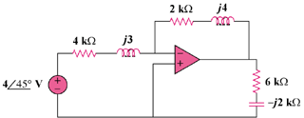

j3 kΩ

j4 kΩ

Figure 11.85
For Prob. 11.66.

Solution

As an inverter,

The power absorbed by the 6-k resistor is

1.92 mW

